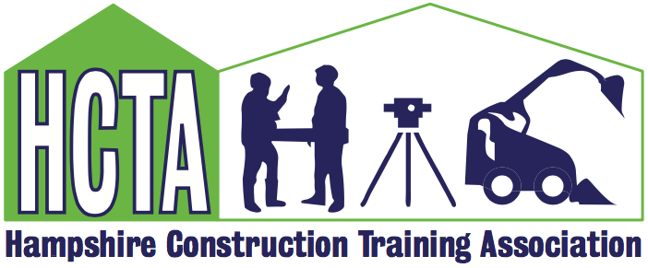
HCTA Members Meeting Tuesday 20th September 2022 10.00am at CETC

Julia Coak, HCTA Chair welcomed everyone to the meeting and confirmed the house keeping rules.

HCTA Update/Future Activity

- AMFA Course planned for 8/9 November- Normally over £300 to attend but HCTA are offering at a cost of £150 – GET grant can also be claimed saving a further £70.
- Effective Communication course to be held on 13th November as part of the progress toward the ‘Stepping Up’ course to be offered once clarification around new L&D CITB standards
- Employers event on 1 November to include tour around newly completed Net0 Hub at Highbury College. Opportunity to engage with potential new members.
- Reminder that training discounts have been negotiated with various companies and are available if mentioned that you are an HCTA member at time of booking. Working towards a comprehensive list that will be on website for reference.
- CITB meeting in London on 12th October

CITB Update
- Jacquee Say provided a comprehensive update with focus on the new Plant standards and grants update New CITB Plant Standards and Grants. The Leadership and Management Commission that will be available free of charge to 10,500 front line managers and supervisors over the next 2.5 years was also discussed. More detail can be found on the presentation that will be uploaded on the HCTA website.

Sunbelt Presentation
- Some HCTA companies have used Sunbelt and their electric plant. Paul Sullivan representing SB gave an interesting insight to his company including their action plan for positive change and the blueprint for a greener future. He also spoke about driving carbon emissions down, helping companies to achieve sustainability goals today, and developing the skills and jobs in the communities is needed for tomorrow. His presentation will be uploaded on the HCTA website for reference and further information with some case studies that support the approach to cleaner energy. If any members would like to tour one of the larger Regional Operation Centres or local depots this can also be arranged. Data from SB operations team relating to client breakdown (number of SMEs we work with vs larger national accounts) has been requested and will be sent to HCTA to share with members.

i-Construct Update

- With only a few weeks to go to this long anticipated event Jason talked through how the day would be managed. There was a full i-Construct meeting that afternoon after the HCTA meeting and some members stayed to participate. Contact Jason if you can help in any way or want more detail: Jason.woodward@ptcontractors.co.uk

AOB
- Carolyn reminded the group that evidence of training activity is required on a quarterly basis by CITB and she would be contacting members to provide brief detail to support the HCTA report
- Request for any ideas of a guest speaker at the next meeting in December – construction related or just fun – all ideas welcomed

Date for next meeting
6th December
Meeting closed at 12.30pm.

